Online Shopping System (Shopee)

Version 1.0

Revision History

|  |  |  |  |
| --- | --- | --- | --- |
| **Date** | **Version** | **Description** | **Author** |
| 07/12/2021 | 1.0 | Final Version | Đỗ Hoàng Duy |

Table of Contents

1. Introduction 4

1.1 Purpose 4

1.2 Scope 4

1.3 Definitions, Acronyms, and Abbreviations 4

1.4 References 4

1.5 Overview 4

2. Flow of Events—Design 5

2.1 Sequence Diagram 5

2.1 Class Diagram 7

3. Derived Requirements 7

# Introduction

## Purpose

This document describes how the Manage Bank Account Use-Case with function: Chat with shopee, Chat with seller is realized within the design model, in terms of collaborating objects.

## Scope

This document applies to the Online Shopping System named Shopee.

## Definitions, Acronyms, and Abbreviations

User – a person who use the system.

Seller – a person who sells products.

## References

No

## Overview

In the following section, Use-Case Realization Specification of the Manage Bank Account UseCase with function: Chat with shopee, Chat with seller of the Shopee System is provided in detail. The first section is a textual description of the Use-Case specification. The following section contains diagrams to describe how the functions work (sequence and class diagrams).

# Flow of Events—Design

## sequence diagram

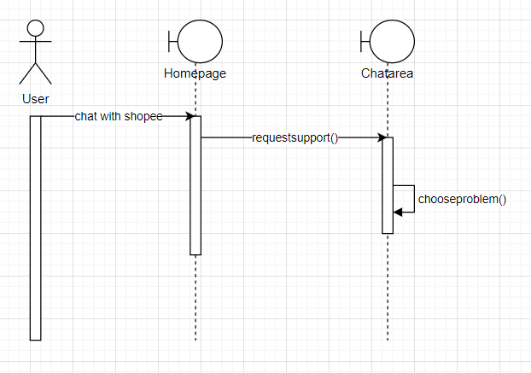

*Chat with shopee*

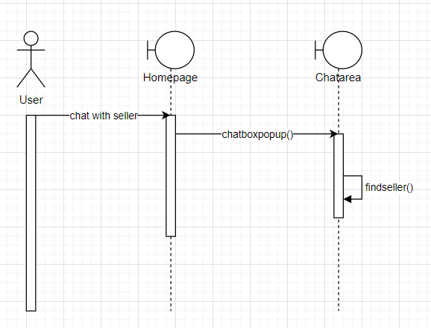

*Chat with seller*

## class diagram

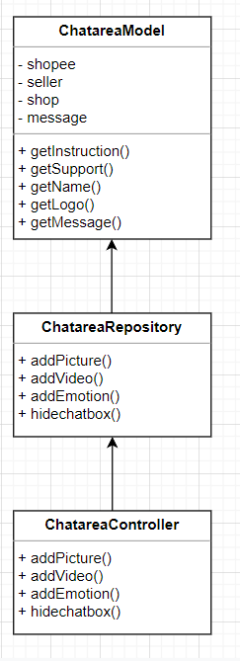

# Derived Requirements

No